SIMATS ENGINEERING
ASSESSMENT TOOL 2

COURSE NAME: INTERNET PROGRAMMING
COURSE CODE: CSA43

COURSE OUTCOME COVERED

CO-1: Develop well-structured, standards-compliant web pages using HTML/XHTML and XML, and apply Internet protocols and HTTP communication mechanisms for web content delivery. (L2)

Assessment Tool : Data Interpretation

Weightage: 20%

QUESTIONS: Total Marks: 20

1: HTTP Response Analysis
A web server returns the following HTTP response header:
HTTP/1.1 200 OK
Date: Mon, 01 Apr 2026 10:00:00 GMT
Content-Type: text/html
Content-Length: -150
Connection: keep-alive
Questions:
- Identify any incorrect or invalid fields in the header.
- Analyze the issue with Content-Length and explain its impact.
- Determine whether the status code matches the response correctness.
- Suggest corrections for the identified errors.

2: DOM Structure Analysis
Consider the following DOM tree representation:
<html>
<head>
<title>Test Page</title>
</head>
<body>
<div>
<p>Hello World
</div>
</body>
</html>
Questions:
- Identify missing or improperly closed elements.
- Analyze how the browser will interpret this structure.
- Determine the impact on rendering and layout.
- Suggest corrections to make the DOM valid.

3: GET vs POST in Login System
A login system uses two different methods:
Method | URL Example | Data Visibility | Security Level
GET | /login?user=admin&pass=1234 | Visible in URL | Low
POST | /login | Hidden in body | Moderate
Questions:
- Interpret the differences in data transmission between GET and POST.
- Analyze which method is more suitable for login and why.
- Identify security risks in using GET for authentication.
- Suggest best practices for secure login implementation.

4: HTML Code Inspection
Analyze the following HTML snippet:
<!DOCTYPE html>
<html>
<head>
<title>Sample</title>
</head>
<body>
<h1>Welcome
<p>This is a paragraph
<img src="image.jpg">
</body>
</html>
Questions:
- Identify missing closing tags.
- Analyze issues with the <img> tag.
- Determine how browsers will handle these errors.
- Suggest a corrected version of the code.

5: Browser-Server Communication Flow
The following sequence describes a web request:
- User enters a URL in the browser
- DNS lookup occurs
- HTTP request is sent
- Server processes request
- Response is returned
- Browser renders page
Questions:
- Interpret each step in the communication flow.
- Identify where delays can occur.
- Analyze the role of DNS in the process.
- Suggest optimizations to improve performance.

ANSWERS:
Question 1: HTTP Response Analysis
Given HTTP response header:
HTTP/1.1 200 OK
Date: Mon, 01 Apr 2026 10:00:00 GMT
Content-Type: text/html
Content-Length: -150
Connection: keep-alive
1. Identify any incorrect or invalid fields in the header.
- Content-Length: -150 is invalid because the content length must be a non-negative decimal integer.
- The Date field has an incorrect weekday. April 1, 2026, is Wednesday, not Monday.
- Content-Type: text/html is valid.
- Connection: keep-alive is valid for HTTP/1.1.
2. Analyze the issue with Content-Length and explain its impact.
The Content-Length header specifies the size of the response body in bytes. A negative value such as -150 is invalid. It may cause the response to be rejected or handled as a malformed message by HTTP software, resulting in communication errors.
3. Determine whether the status code matches the response correctness.
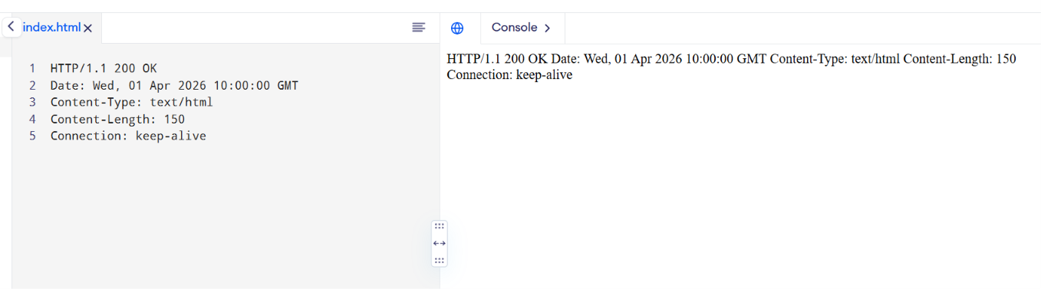
The status code 200 OK indicates that the request was successfully processed. However, the invalid Content-Length and incorrect date make the response header malformed. Therefore, 200 OK alone does not guarantee that the response is correctly formatted.

Question 2: DOM Structure Analysis
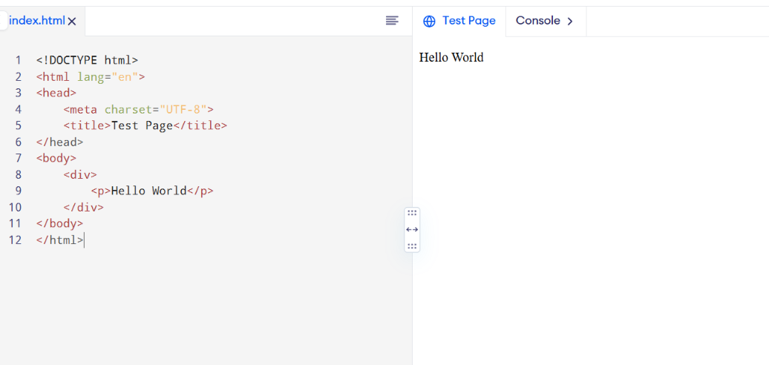
1. Identify missing or improperly closed elements.
The <p> element is missing its closing </p> tag before the </div> tag. The document also lacks a DOCTYPE declaration and the lang attribute on the <html> element.
2. Analyze how the browser will interpret this structure.
HTML browsers use error-recovery rules to construct the DOM. When the parser encounters </div>, it implicitly closes the open paragraph in this example. As a result, the browser may still display the page without showing an obvious error.
3. Determine the impact on rendering and layout.
- The browser may automatically repair the HTML structure.
- The paragraph may render correctly despite the missing closing tag.
- Unexpected nesting can affect CSS styling and JavaScript DOM operations.
- Missing a DOCTYPE may cause quirks mode, which can affect layout consistency.

Question 3: GET vs POST in Login System
1. Interpret the differences in data transmission between GET and POST.
GET | POST
Sends form data in the URL query string. | Sends form data in the request body.
Data may appear in browser history and server logs. | Data is not normally displayed in the URL.
Primarily used to retrieve information. | Commonly used to submit information or perform actions.
Not suitable for passwords. | More appropriate for submitting login credentials.
2. Analyze which method is more suitable for login and why.
The POST method is more suitable for login systems because credentials are transmitted in the request body rather than being placed in the URL. This reduces accidental exposure through browser history and URL sharing.
However, POST alone does not encrypt the data. HTTPS is required to protect credentials during transmission.
3. Identify security risks in using GET for authentication.
- Passwords may appear in browser history.
- URLs may be stored in server logs.
- URLs can be copied, bookmarked, or shared accidentally.
- Query parameters may be exposed through monitoring tools or other systems.
- Sensitive credentials may be disclosed unintentionally.
4. Suggest best practices for secure login implementation.
- Use HTTPS with TLS encryption.
- Submit credentials using POST.
- Validate credentials on the server.
- Store passwords using a secure password-hashing algorithm.
- Use secure session cookies with HttpOnly, Secure, and appropriate SameSite settings.
- Apply rate limiting to prevent brute-force attacks.
- Avoid storing passwords in URLs, logs, or browser storage.

Question 4: HTML Code Inspection
HTML output:
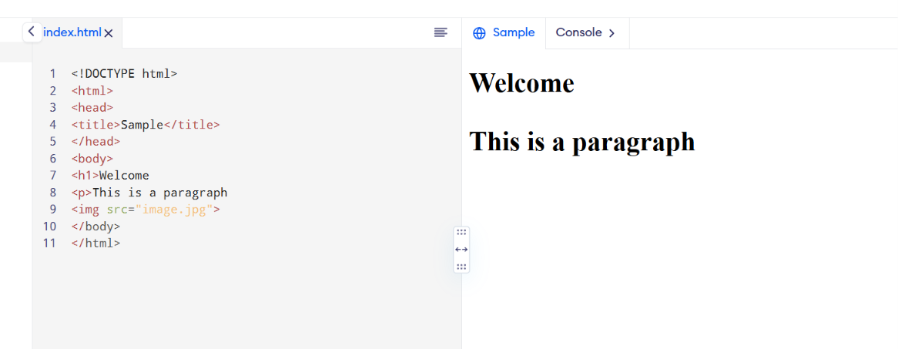
1. Identify missing closing tags.
- The <h1> element is missing </h1>.
- The <p> element is missing </p>.
The <img> element is a void element in HTML and does not require a closing tag.
2. Analyze issues with the <img> tag.
The image tag has a src attribute but lacks an alt attribute. The alt attribute provides alternative text for users who cannot see the image and for situations where the image fails to load.
3. Determine how browsers will handle these errors.
Browsers may automatically close the heading and paragraph elements during HTML parsing and still display the webpage. However, relying on automatic correction can lead to inconsistent structure, accessibility problems, and unexpected styling behavior.

Question 5: Browser-Server Communication Flow
1. Interpret each step in the communication flow.
Step 1: User enters a URL
The user enters a website address in the browser, such as https://example.com.
Step 2: DNS lookup occurs
The Domain Name System (DNS) resolves the domain name into an IP address so the browser can locate the server.
Step 3: HTTP request is sent
The browser establishes the necessary connection and sends an HTTP request containing the method, path, headers, and possibly a request body.
Step 4: Server processes the request
The server receives the request, executes the required application logic, and retrieves or generates the requested content.
Step 5: Response is returned
The server sends an HTTP response containing a status code, headers, and possibly a response body.
Step 6: Browser renders the page
The browser interprets HTML, applies CSS, executes JavaScript, and displays the webpage. It may also request additional resources such as images and stylesheets.
2. Identify where delays can occur.
- DNS resolution may take time.
- Establishing a TCP connection or TLS handshake may introduce latency.
- Network congestion can delay requests and responses.
- Server processing or database queries may be slow.
- Large HTML, CSS, JavaScript, and image files may take longer to download.
- Browser rendering and JavaScript execution may delay page display.
3. Analyze the role of DNS in the process.
DNS translates human-readable domain names into IP addresses. It allows users to access websites without remembering numerical IP addresses.
DNS caching reduces repeated lookups and can improve loading speed. If DNS resolution fails, the browser may be unable to locate the server.

4. Suggest optimizations to improve performance.
- Use DNS caching and a reliable DNS service.
- Use a Content Delivery Network (CDN) to serve resources closer to users.
- Compress responses using Brotli or gzip.
- Optimize images and minimize unnecessary JavaScript and CSS.
- Enable browser caching for static resources.
- Optimize server-side processing and database queries.
- Use HTTP/2 or HTTP/3 where supported.
- Reduce unnecessary HTTP requests and use lazy loading for suitable images.

Code of Conduct:

I K.Reddy Srija(192372365) (Name / Reg No) certify that this submission is my original work and that I have adhered to the guidelines specified for this assessment.
I understand that any violation of academic integrity rules will result in disciplinary action.

Signature of the student:
K.Reddy Srija

RUBRICS FOR CALCULATION:

Criteria | Weightage | Level 4 (Exemplary) | Level 3 (Proficient) | Level 2 (Developing) | Level 1 (Beginning)
Understanding of Data | 25% | Accurately interprets all data patterns, trends, and relationships | Interprets data correctly with minor gaps | Partial understanding; misses key trends | Misinterprets or fails to understand data
Analysis | 25% | Provides deep analysis with strong logical reasoning and justification | Provides reasonable analysis with some justification | Basic analysis with weak reasoning | No meaningful analysis provided
Application of Concepts | 20% | Effectively applies relevant concepts/tools to interpret data accurately | Applies concepts with minor errors | Limited application; requires guidance | Unable to apply concepts to data
Conclusion | 20% | Draws clear, meaningful conclusions with strong insights and implications | Provides valid conclusions with moderate insights | Conclusions are vague or weak | No clear or valid conclusions
Clarity | 10% | Presents interpretation clearly using proper structure, visuals, and terminology | Generally clear with minor issues | Lacks clarity or proper structure | Poor presentation and difficult to understand

